Lay summary

Aim
To explore which outcomes matter most to patients undergoing major surgery.

Background
Every year, almost 10 million operations are performed in the UK. Most go well, but 10-15% of patients suffer medical complications, and 1-3% are fatal. Even the operations that ‘go well’ may not be completely successful from the patient’s viewpoint – but we don’t know, because we don’t always collect the right outcome data. Moreover, we’re not sure which outcomes really matter, because we’ve never asked a broad range of surgical patients.
This study seeks to define patient-centred outcomes after major surgery. It addresses one of the top priorities for UK perioperative research highlighted in a recent research prioritisation exercise,* namely ‘What outcomes should we use to measure the 'success' of anaesthesia and perioperative care?’ Our research group aims to develop ‘Core Outcome Measures’ for anaesthesia and perioperative care – outcomes which are so fundamental, they should be reported in all research trials.
However, we need to be sure that our outcome measures are truly relevant to patients. We therefore wish to explore the views of patients and carers with experience of major surgery, and the healthcare professionals looking after them, about what matters most to them.

Methodology
Design: This study will involve surveys and in-depth interviews of adult patients, their carers and healthcare professionals with experience of major surgery (any big operation where patients are admitted to hospital).
Intervention: 1) We will ask patients, carers and healthcare professionals to complete a short survey (approximately ten minutes) to rate the importance of seven commonly used post-operative outcome measures on a scale of 0-10. The survey will also ask them to suggest any other outcomes they think are important, and some basic demographic information. We aim to recruit at least 150-200 survey respondents, which will allow us to analyse differences between clinicians’ views and those of patients and carers.
2) Survey respondents will also be asked if they are willing to have a telephone interview to explore their views on post-operative outcomes in greater depth. We will aim for 40-60 interviews, or until no ‘new’ viewpoints or perspectives are obtained (termed ‘theoretical saturation’). Interviews will be recorded and thematically analysed to extract the major themes. They will be ‘semi-structured’, i.e. the precise questions and content is not fixed, but will seek to explore participants’ views about the following research questions:
- How do patients / carers / clinicians evaluate the results of major surgery?
- Which factors do patients and clinicians consider when making decisions about having surgery? How do they come to their decisions?
- Which ‘outcomes’ after major surgery are patients / carers / clinicians most interested in?

Expected results and implications:
The views of patients, carers and clinicians will help us define patient-centred outcomes for major surgery. These will inform a global consensus-based initiative to agree standardised, patient-centred Core Outcome Measures to improve the consistency and patient relevance of future perioperative research.

The P-COMMaS Research Team:
Dr Ramani Moonesinghe (Chief Investigator) University College Hospital, London
Dr Oliver Boney (Study Coordinator) University College Hospital, London
Professor Mike Grocott (Co-Investigator) University Hospital, Southampton
Ms Jacqui Gath (Patient expert) Independent Cancer Patients’ Voice
Ms Marion Cumbers (Patient expert) Royal National Orthopaedic Hospital Patient Group
Chief Investigator: Dr Ramani Moonesinghe Email: rmoonesinghe@googlemail.com
Study Coordinator: Dr Oliver Boney Email: oliver.boney@nhs.net
UCL Surgical Outcomes Research Centre, University College Hospital, 235 Euston Road, London, NW1 2BU
Tel: 020 3456 7014

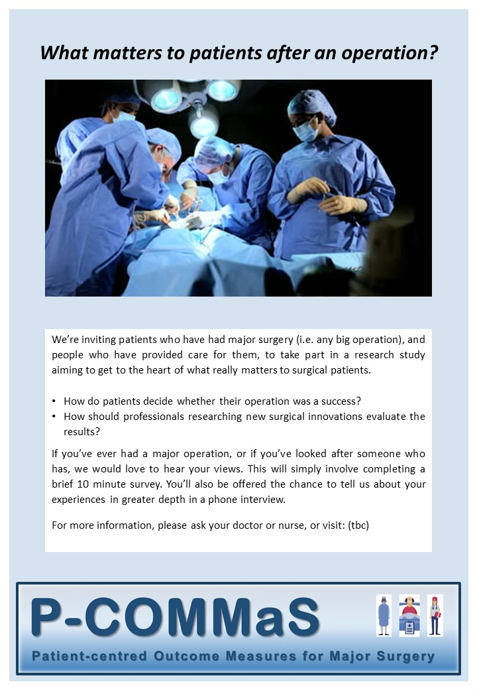

* The James Lind Allliance / National Institute for Academic Anaesthesia Anaesthesia and Perioperative Care Priority Setting Partnership

